**Configuration in Nginx**

1. Installation of Nginx:

* Type command “sudo su” so that you can have the resources of the super user
* Then type “sudo apt update”

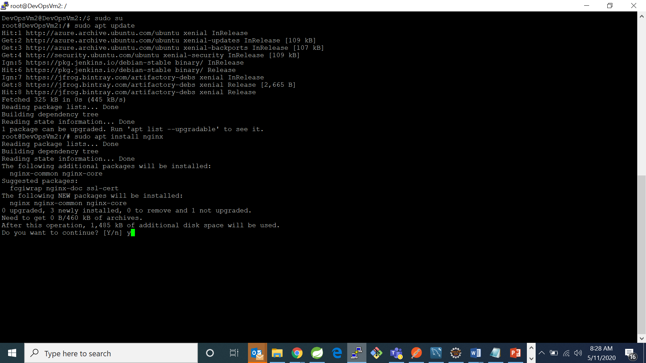

* Type command “sudo apt install nginx” to install nginx

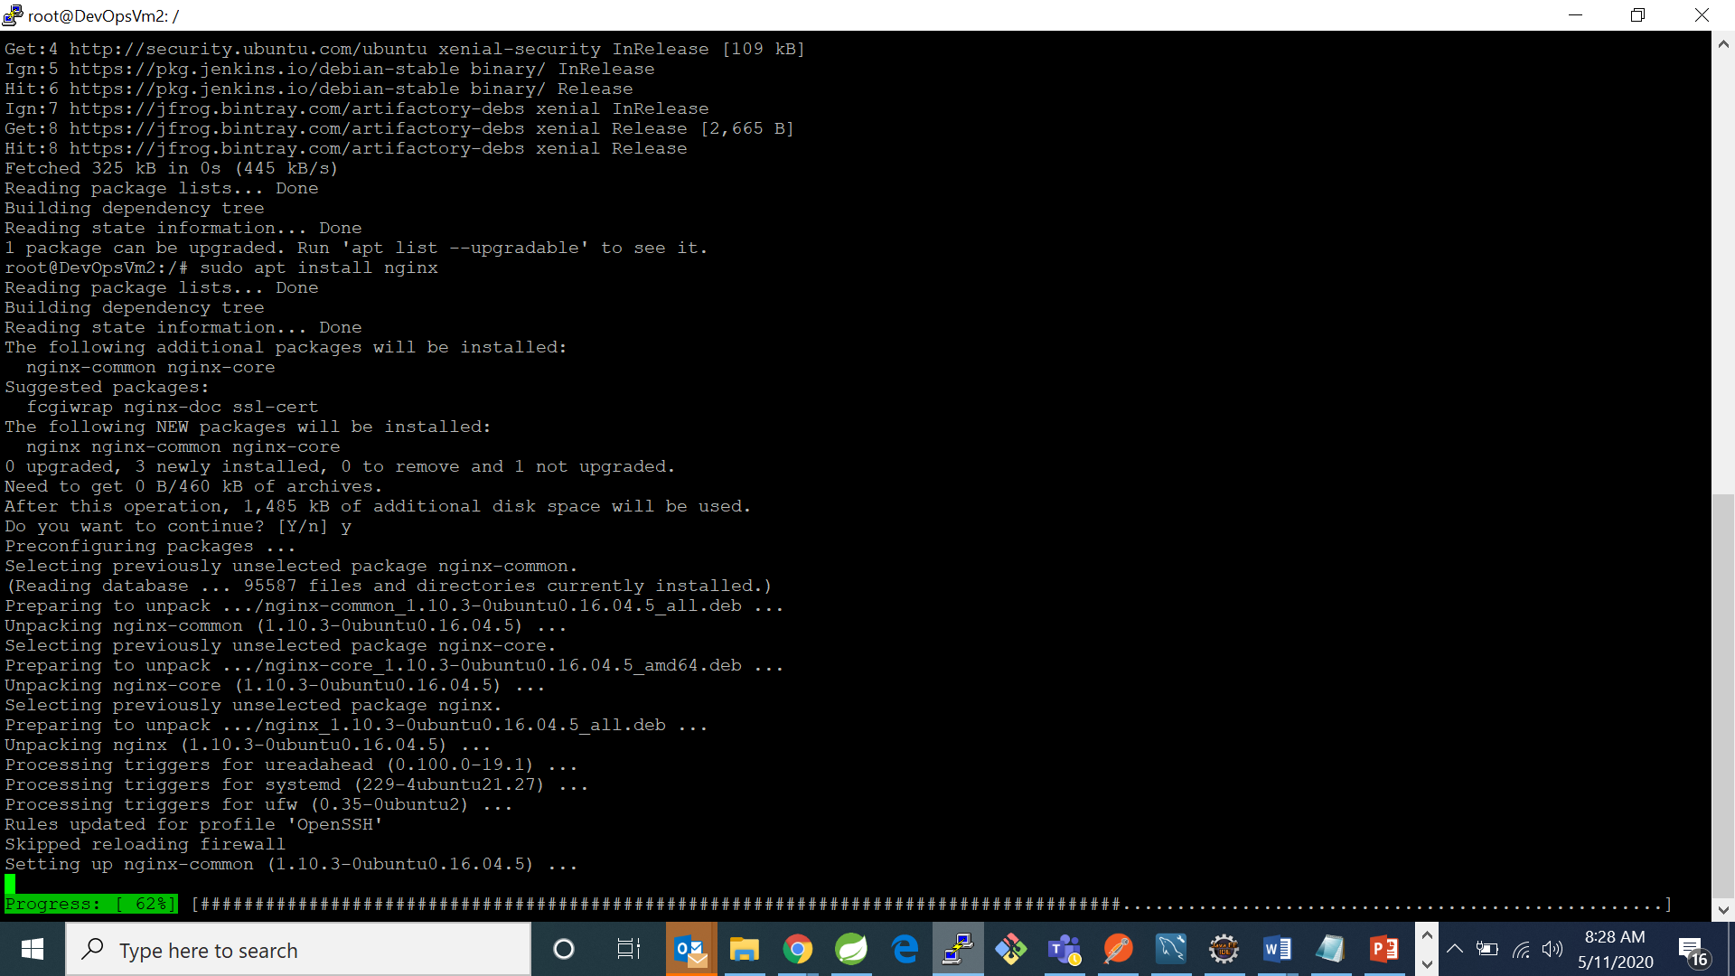

* Now type command “sudo nano /etc/nginx/sites-available/default” and change the port in listen directive name in server context. By default it is 8080 port.

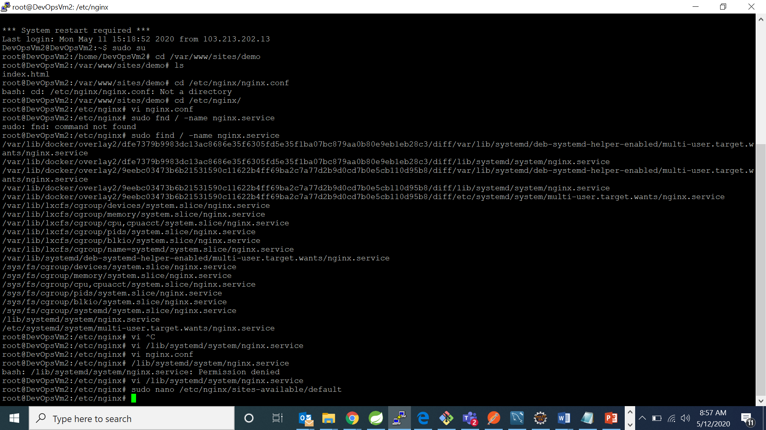

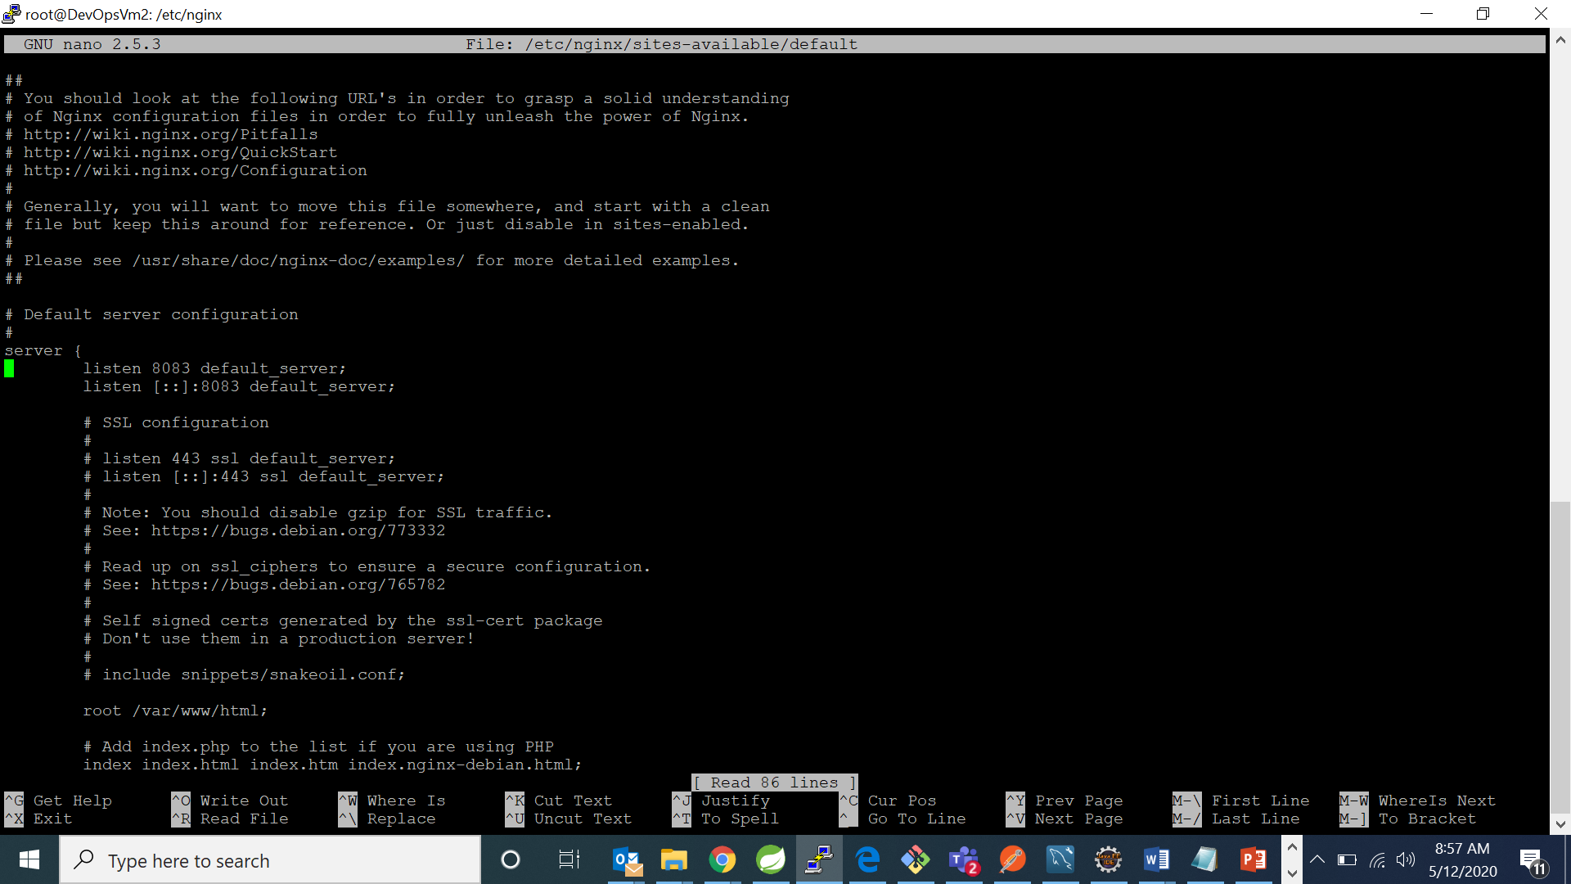

* Now type command “systemctl daemon-reload”

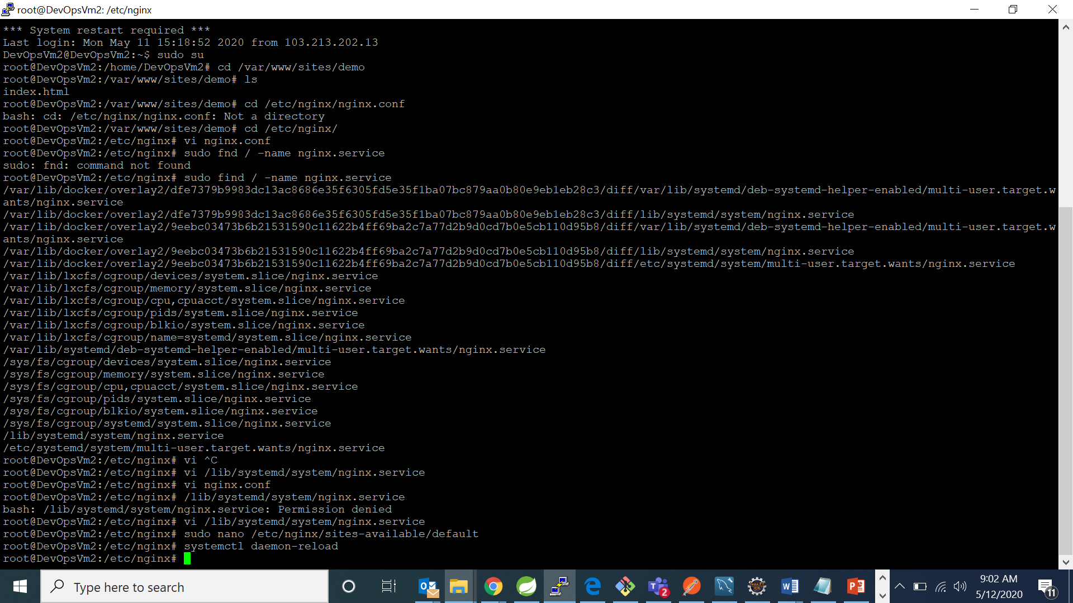

* Now go browser and check at your provided port:

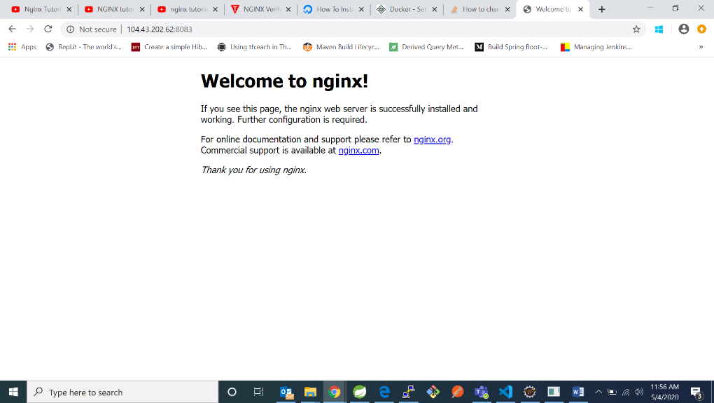

1. Now type command “cd /var/www” and “mkdir sites”

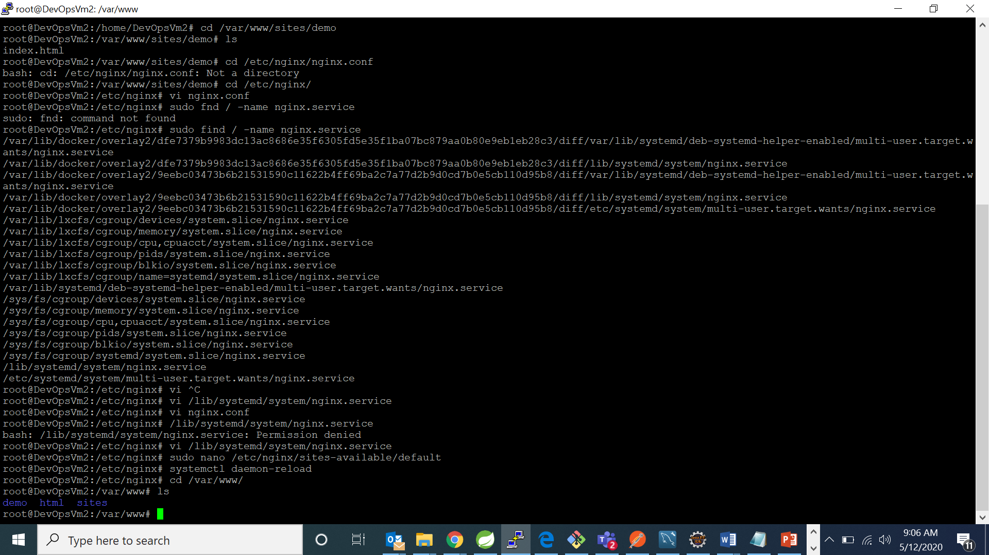



1. Now type “cd sites” and “mkdir demo” and then “cd demo”

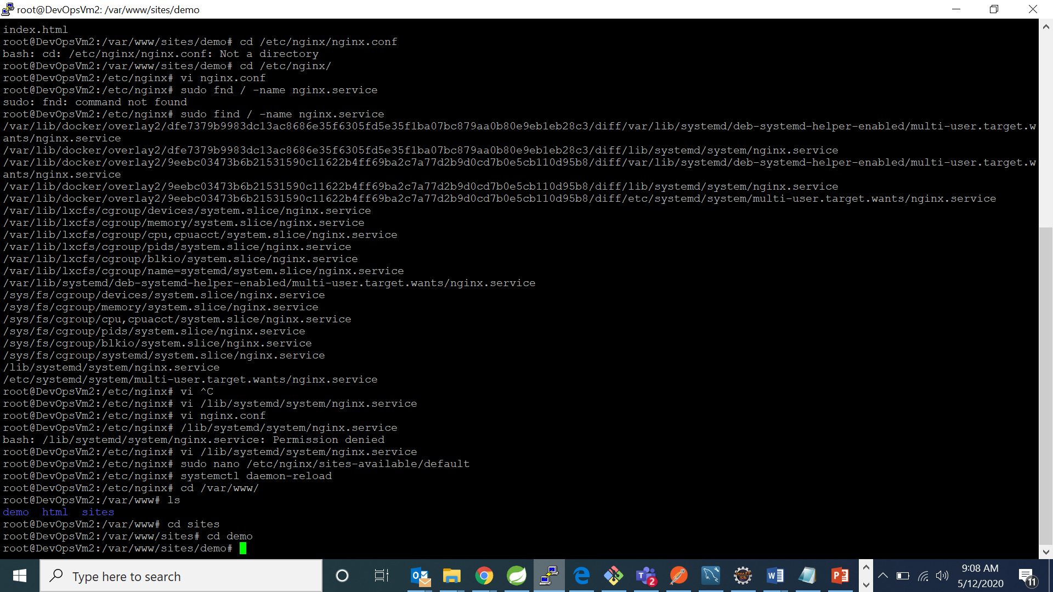

1. Now create a index.html using command “vi index.html”. It will open the editor if your file is not created also it will create. In the editor write your code

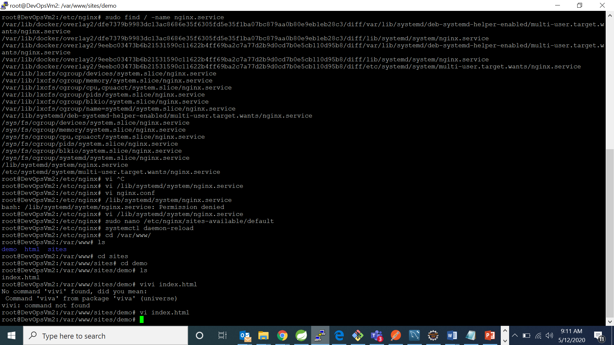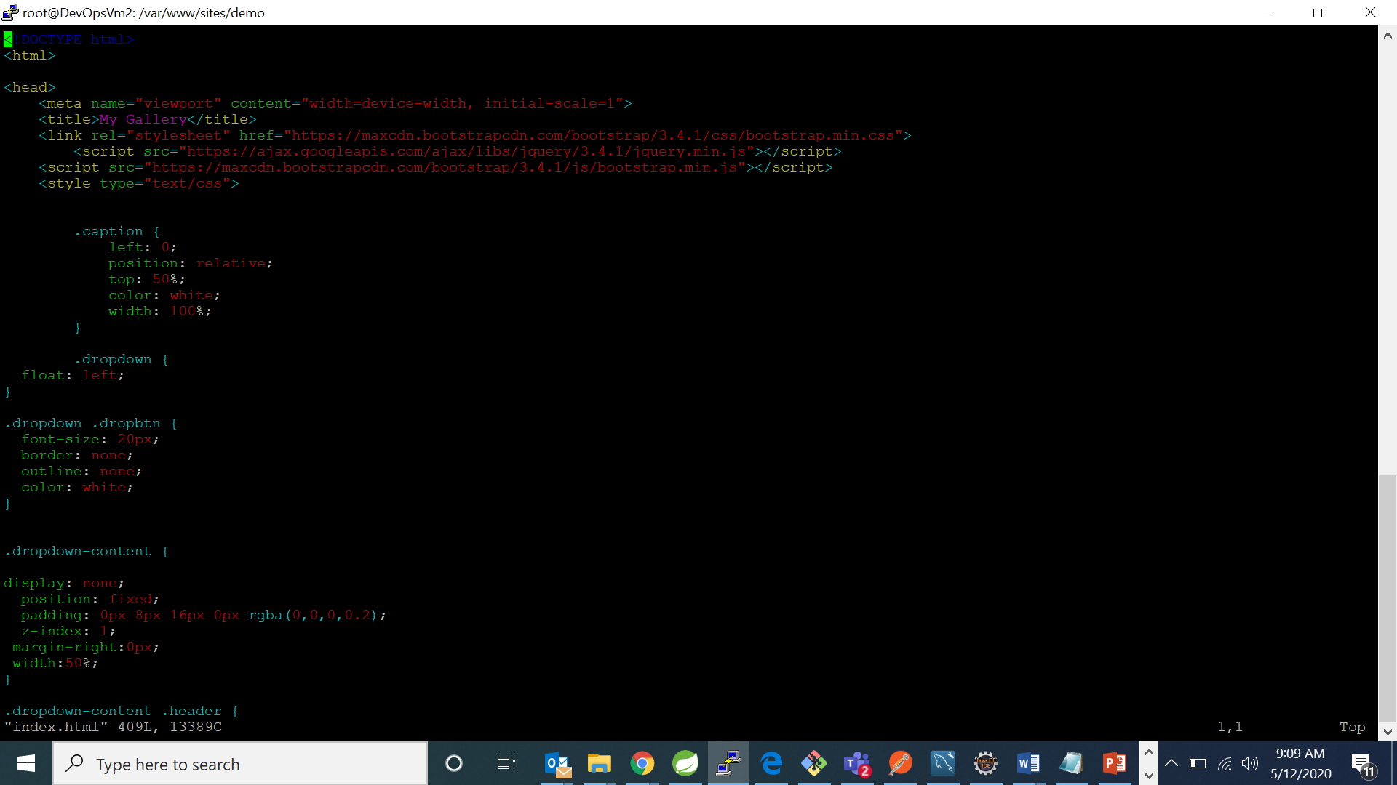

1. Now type command “sudo nano /etc/nginx/nginx.conf”. It will open the editor for you to make changes in that file.

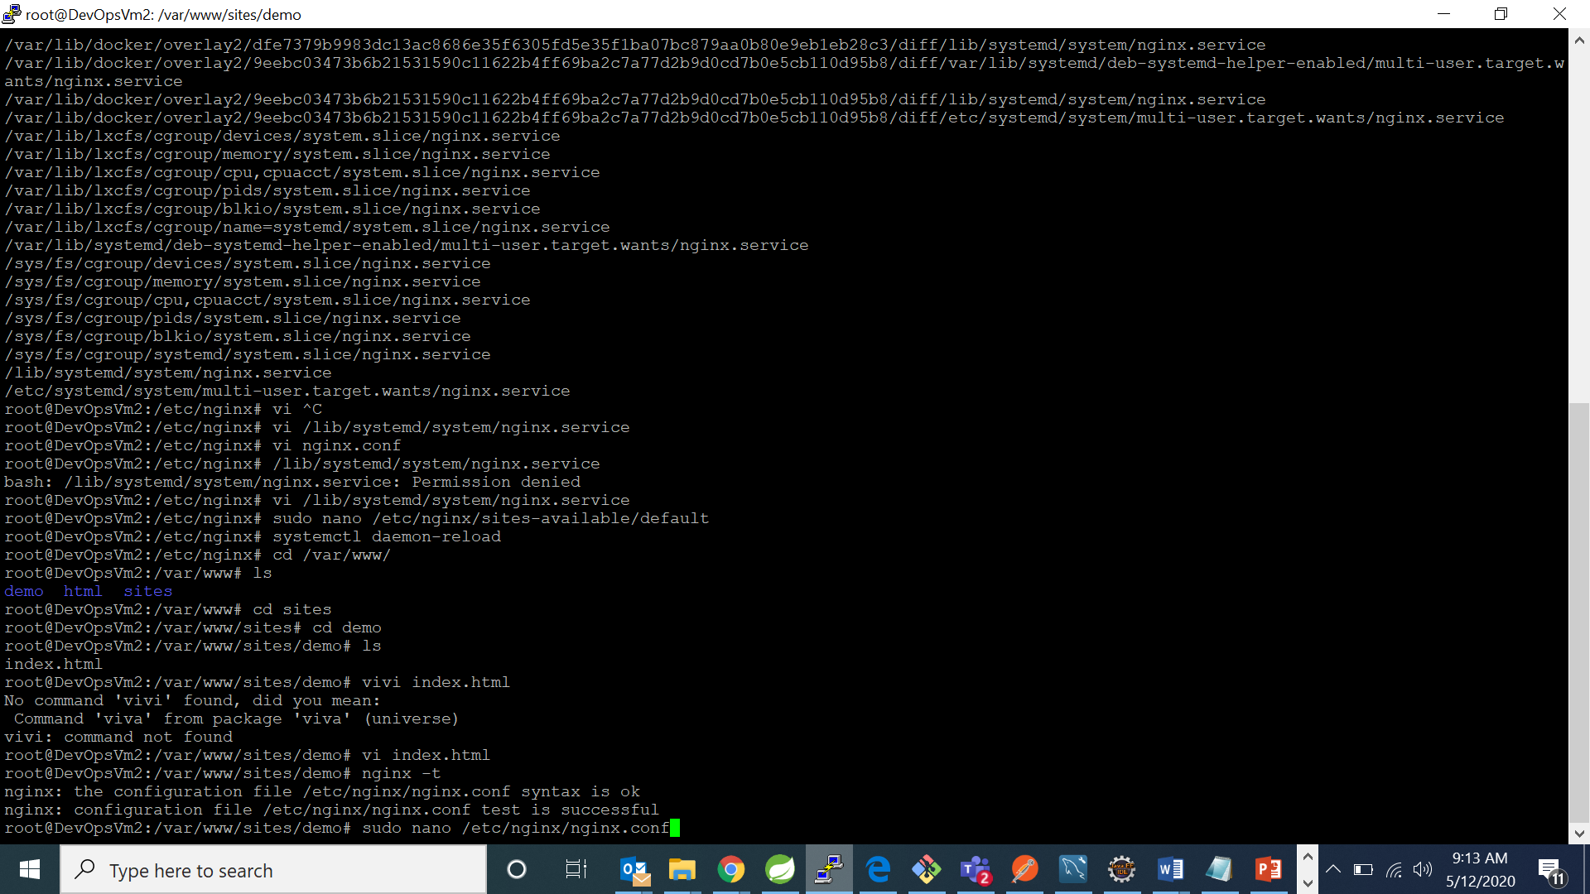

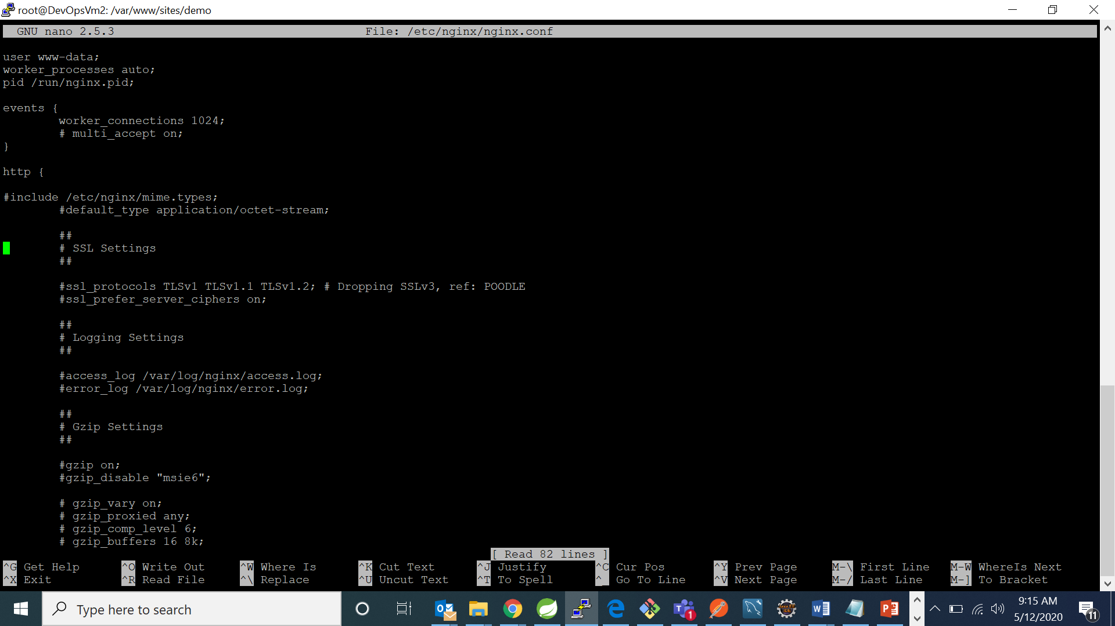

1. Now go to http context and create another context inside it named server and write down the following:

server{

listen 8083;

server_name 104.43.202.62;

root /var/www/sites/demo;

}

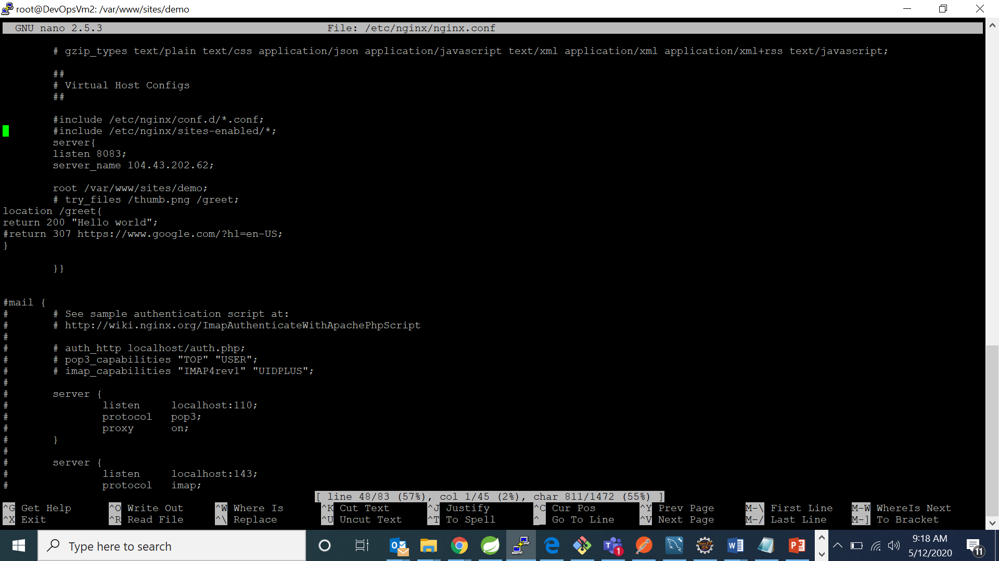

1. Now type command “nginx -t” . It will check for configuration errors or status and will let you know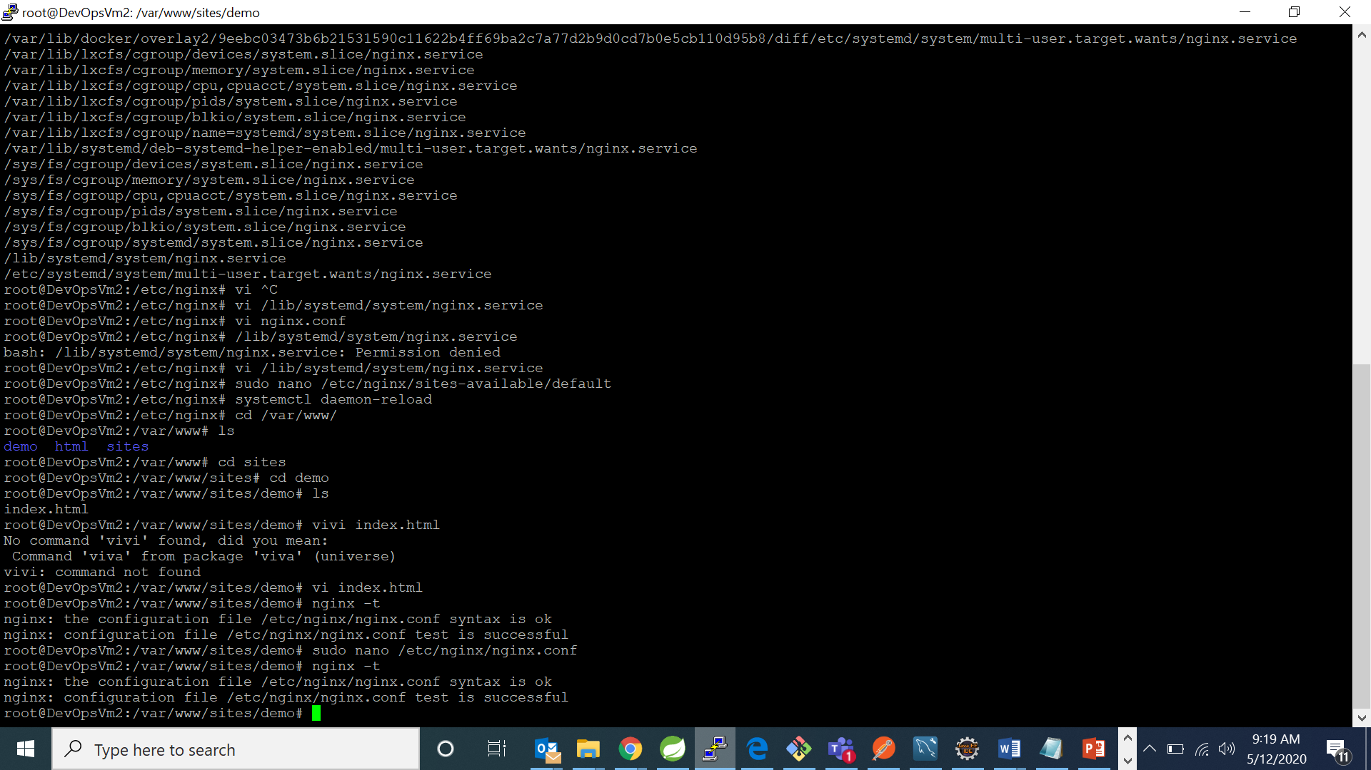
2. Now type command “systemctl reload nginx” that reload all your changes made to configuration file.

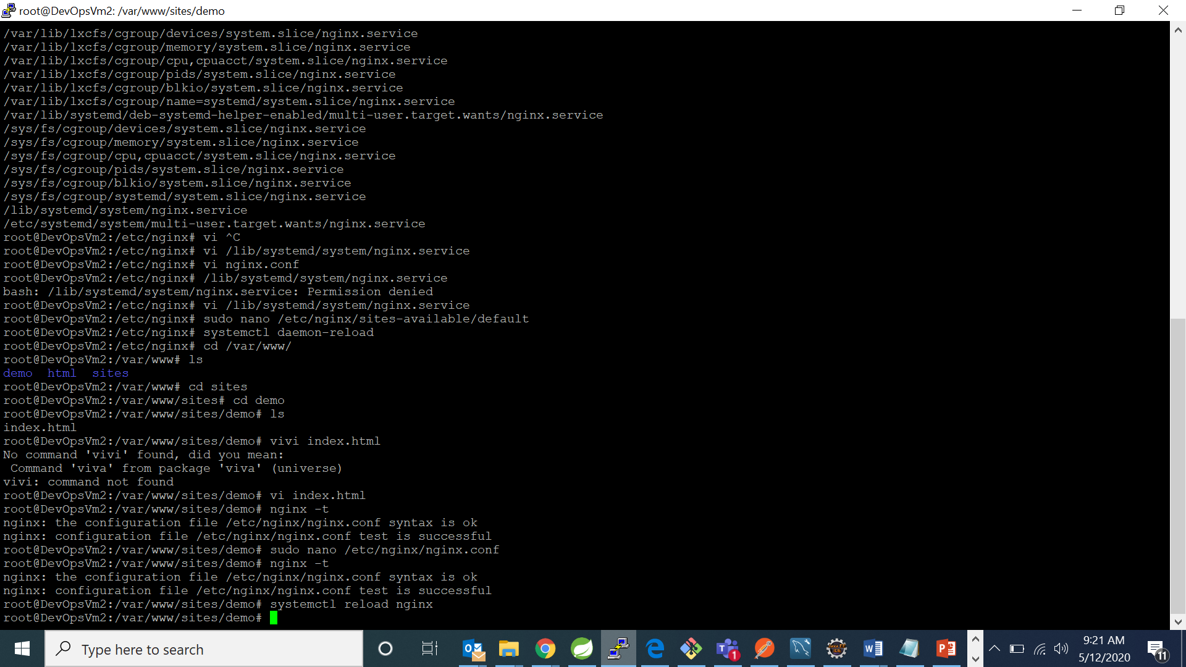

1. Now go to browser and check for your changes:



If your browser displays according to your configuration then we have successfully mae our configuration.

**FOR REVERSE PROXY:**

1. Now type command “sudo nano /etc/nginx/nginx.conf”. It will open the editor for you to make changes in that file.



1. Make location directive in the server context in nginx.conf and write down the following:

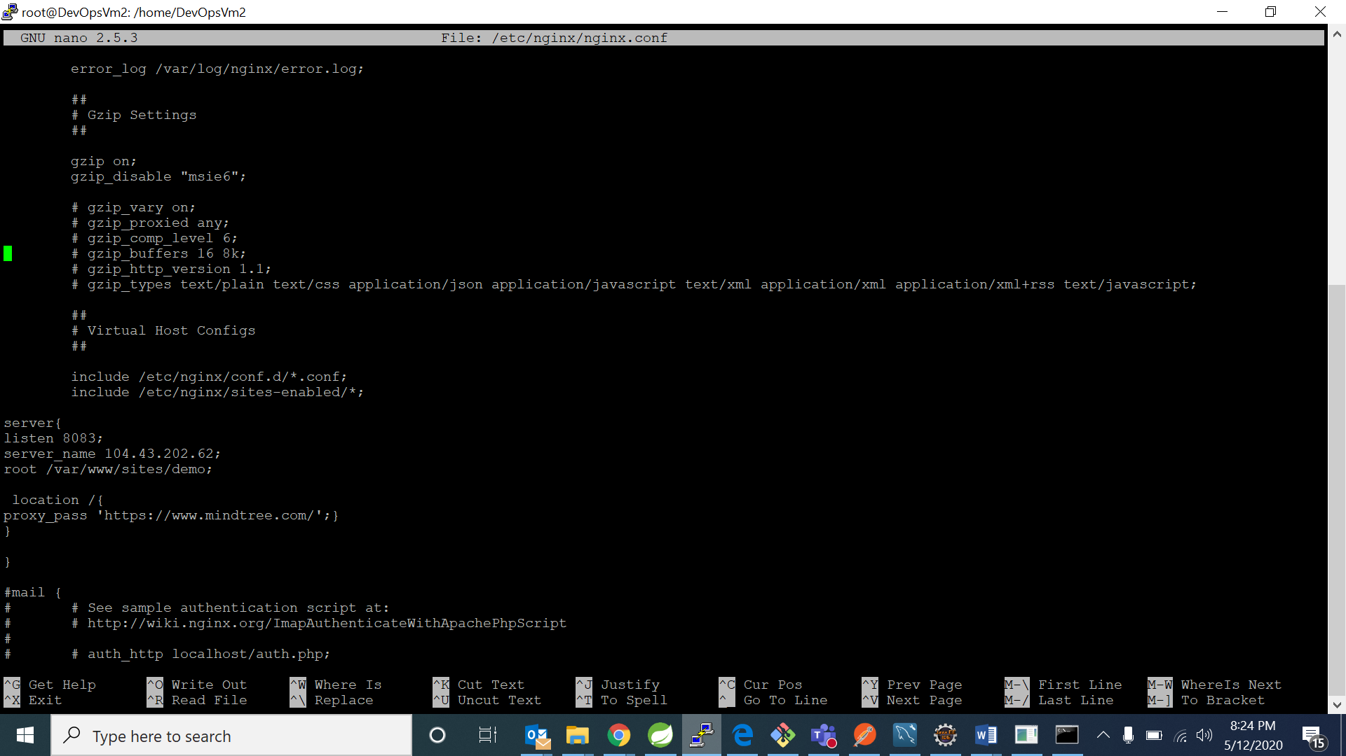

1. Now type command “nginx –t” too check if the configurations made by you are correct and if it is successful and type command “systemctl reload nginx”

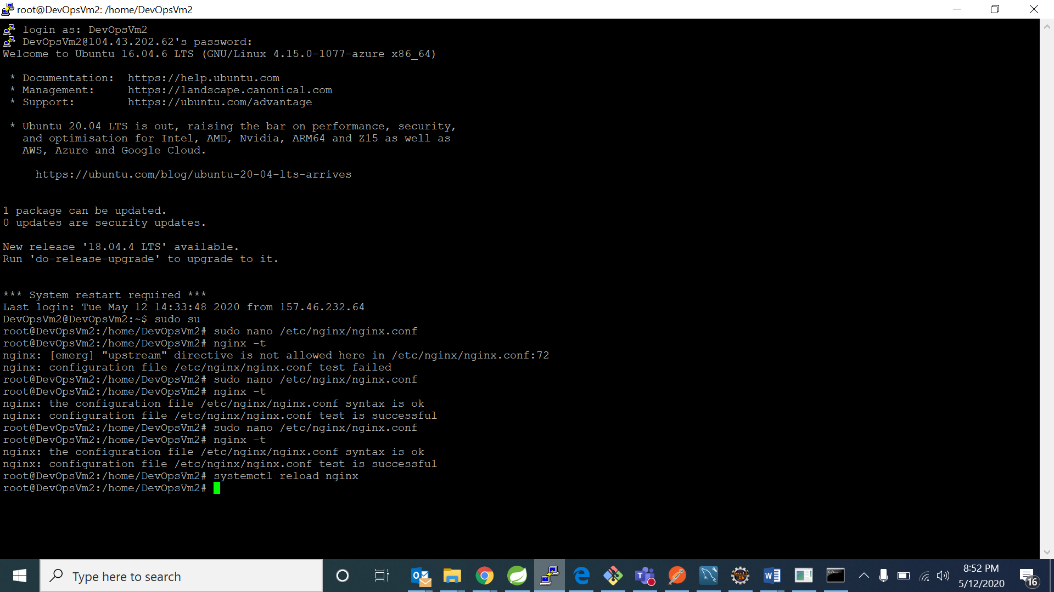

1. Now go to browser and check for the ip address of your vm and for port 8083



FOR LOAD BALANCING

1. Now type command “sudo nano /etc/nginx/nginx.conf”. It will open the editor for you to make changes in that file.



1. Make location directive in the server context in nginx.conf and write down the following:

server{

listen 8083;

server_name 104.43.202.62;

root /var/www/sites/demo;

location /{

proxy_pass 'https://www.mindtree.com/';}

}

upstream remote_application_server{

server 104.43.202.62:8080;

server 104.43.202.62:8081;

server 104.43.202.62:8082;

}

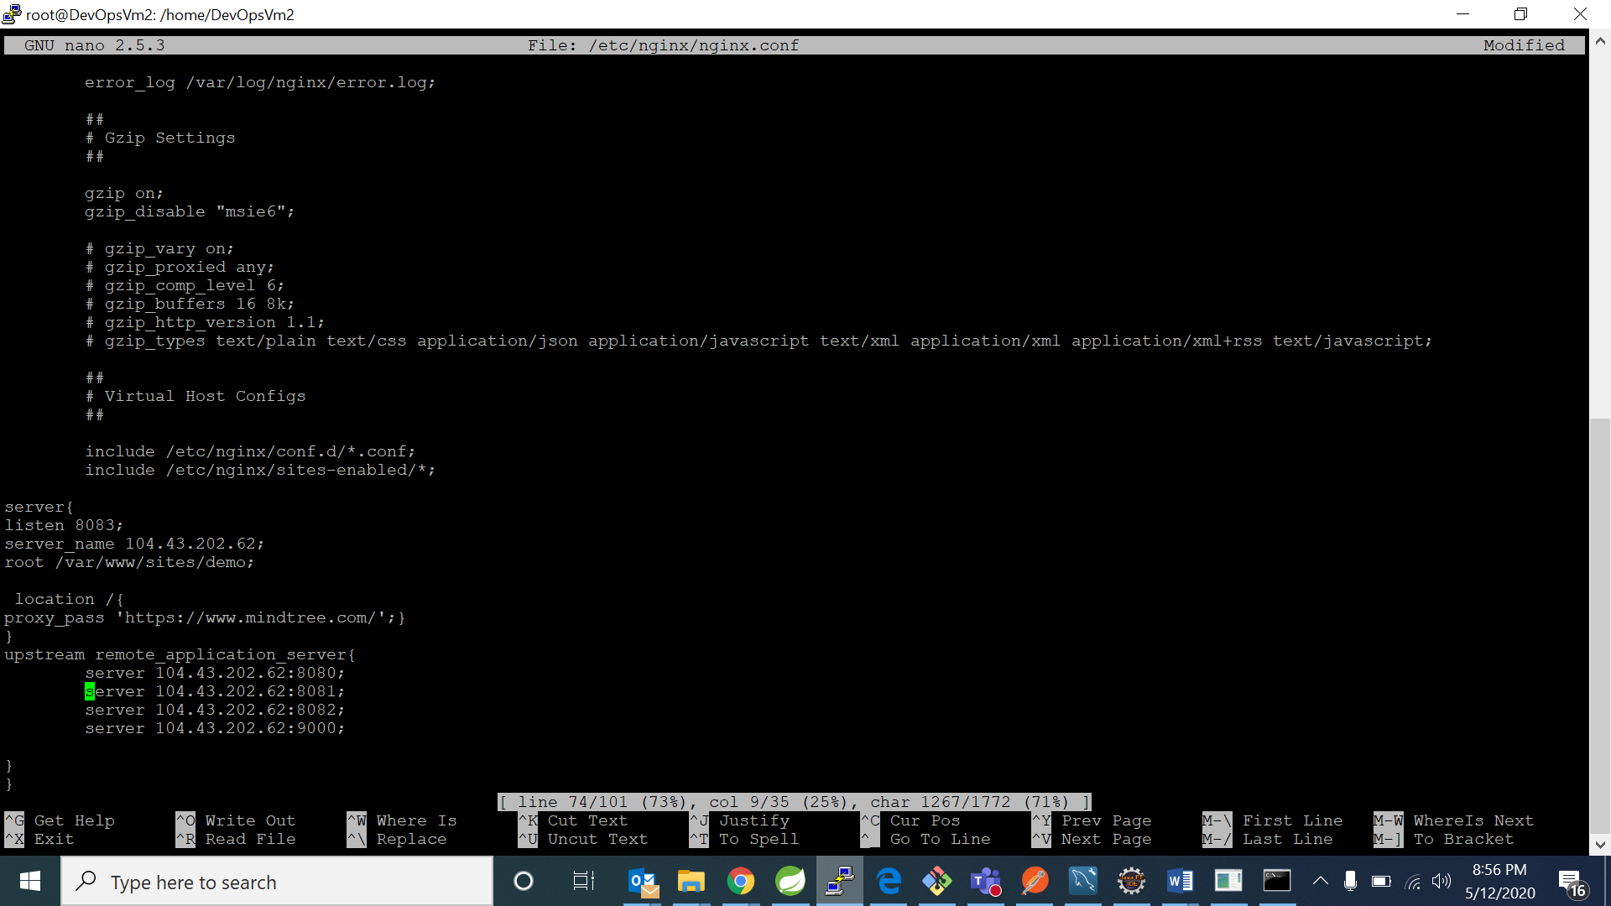

1. Now type command “nginx –t” too check if the configurations made by you are correct and if it is successful and type command “systemctl reload nginx”



My jenkins is working on 8083 port

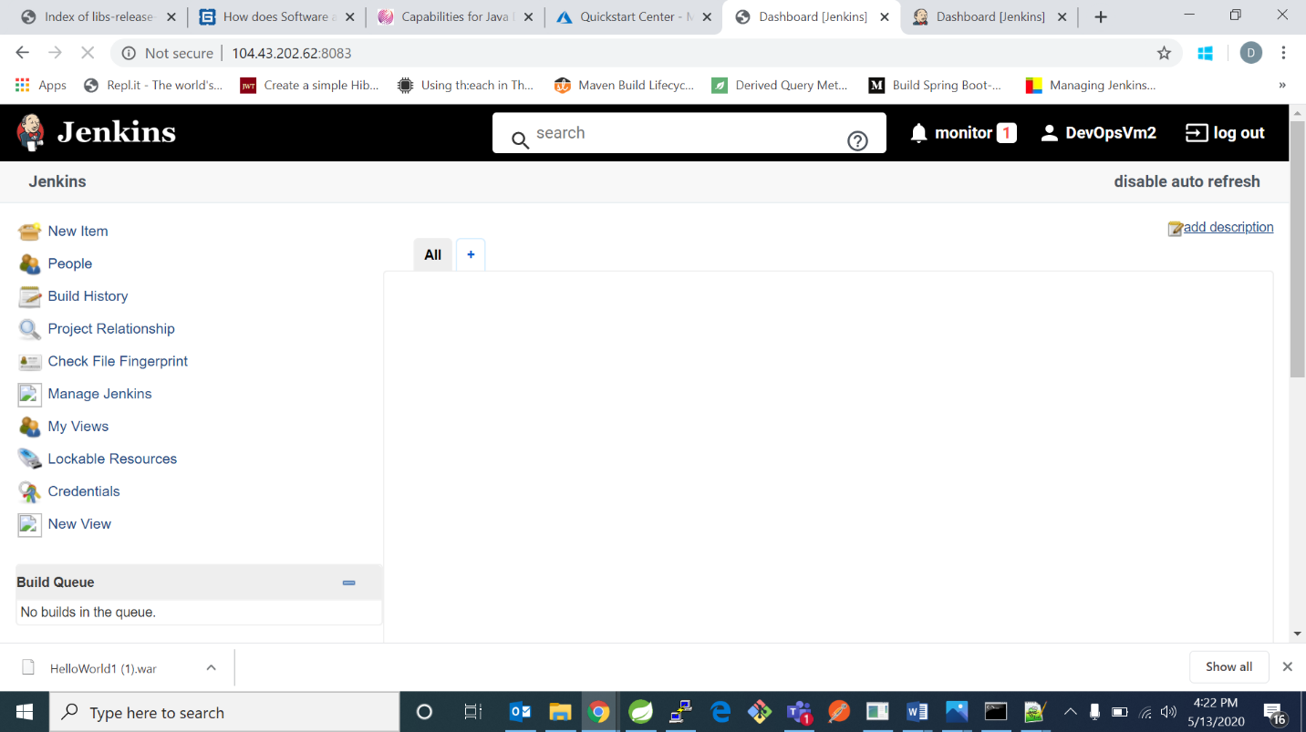

My tomcat is also working on same port 8083 after hitting the url again

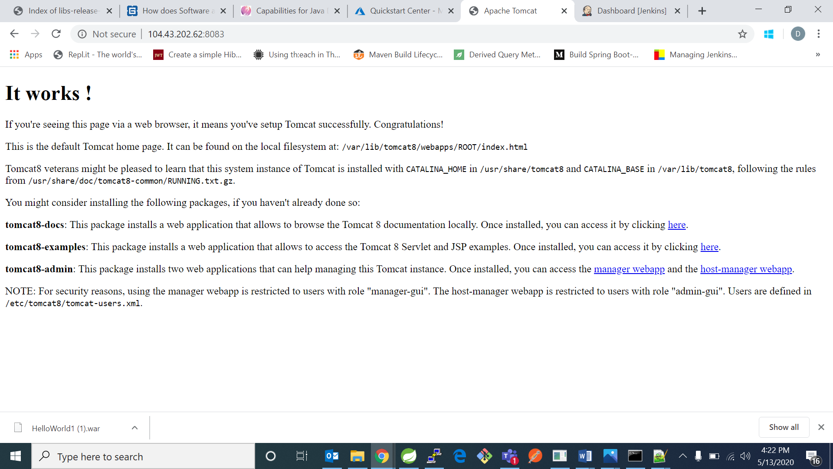

My jfrog artifactory is also working on same port 8083 after hitting again

